Question 1/4: Vectors (5 points)
Write a method void removeDoubles() on the Vector class that traverses removes all duplicates in a vector. A duplicate is an element that occurs exactly twice in the vector.

For example, after calling removeDoubles() on the following vector:

[1, 2, 3, 3, 2, 4, 1, 5, 5, 5, 7]

will result in a vector containing the following elements:

[4, 5, 7]

The elements 1, 2 and 3 are completely removed as they occur exactly two times. The element 5 is kept as it occurs more than 3 times. The element 7 is kept as it occurs less than two times.

What is the time complexity of your algorithm?

Question 2/4: Trees (6 points)
A different way to store a binary search tree than the method we have seen in class, is to store all the data in a vector. Every element in the tree corresponds to a position in the array, according to a fixed rule. The root is stored in the array on position 1, and for every element stored at position i, the left child is stored at position 2*i and the right child is stored at position 2*i+1.
For instance, for the tree on the left, the corresponding vector is given on the right
0 | 1 | 2 | 3 | 4 | 5 | 6 | 7 | 8 | 9 | 10 | 11 | 12 | 13 | 14
/ | 8 | 3 | 10 | 1 | 6 |  | 14 |  |  | 4 | 7 |  |  | 13
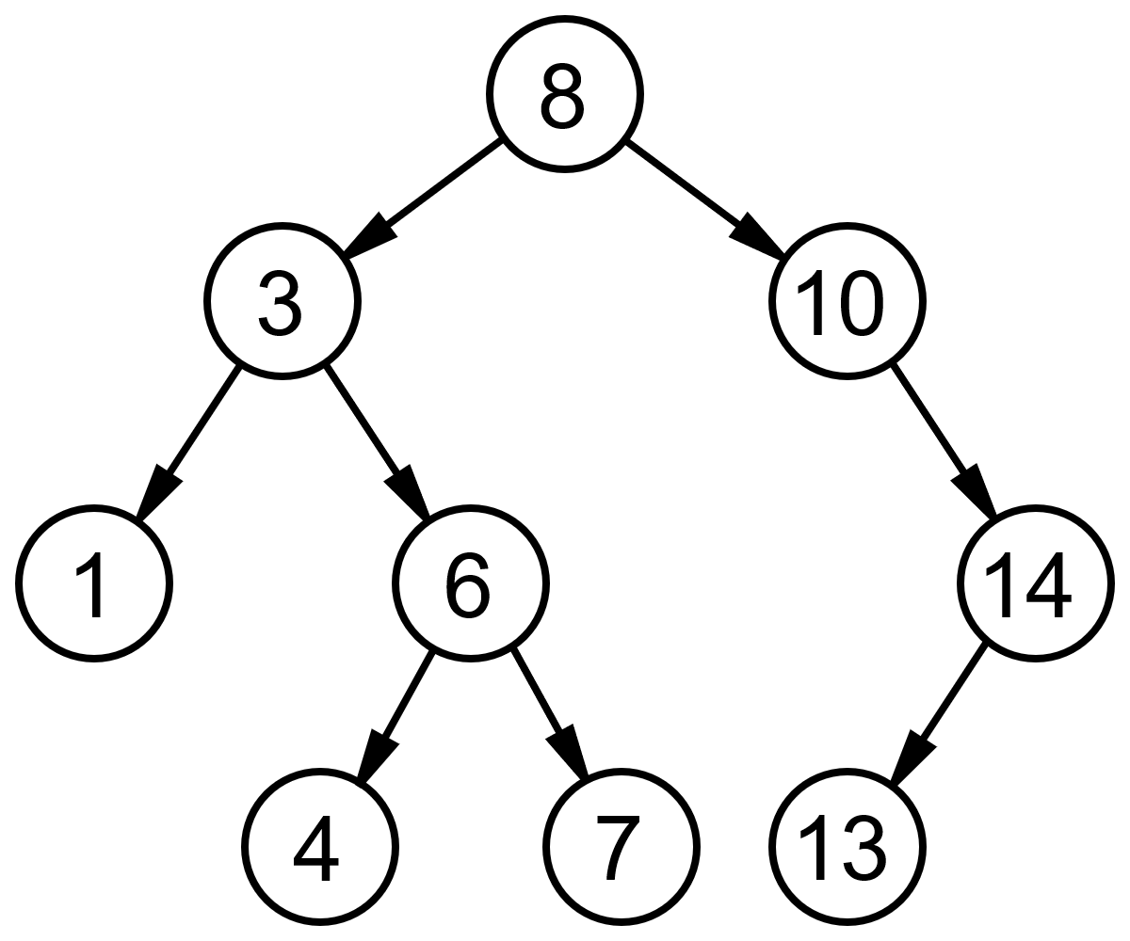

- Implement a method SetLeftChild(int index, Comparable value) which takes the index in the vector of the current node and assigns the given value to the left child.
- A method “swap” on a binary search tree mirrors the tree, i.e the left and right children are swapped. For instance, in the picture below, the tree and its swapped version are shown. Implement a method swap on a binary search tree stored in a vector as explained above. Use SetLeftChild and SetRightChild (you can assume this method exists).
- What is the time complexity of your swap method. Motivate.

Question 3/4 (4 points)
Assume a circular structure called Circular double linked list. This structure is similar to Double linked list, but the elements are chained in a circle, meaning the predecessor of the first element is the last element and the successor of the last element is the first element. Write the methods addFirst(Object val), addLast(Object val); removeFirst(), removeLast() and find(Object val).

Question 4/4: (5 points)
Consider a directed acyclic graph. A “transpose” of a graphs is the same graph, with all edges transposed, i.e. an edge from node i to node j is transposed into an edge from node j to node i. Write a transpose method on a graph in edge list representation. Motivate the time complexity of the method.

Provided Code
Vector

public class Vector {
protected Object data[];
protected int count;

public Vector(int capacity) {
data = new Object[capacity];
count = 0;
}

public int size() {
return count;
}

public boolean isEmpty() {
return size() == 0;
}

public Object get(int index) {
return data[index];
}

public void set(int index, Object obj) {
data[index] = obj;
}

public boolean contains(Object obj) {
for(int i=0;i<count;i++) {
if(data[i] == obj) return true;
}
return false;
}

public void addFirst(Object item) { … }

public void addLast(Object o) {
data[count] = o;
count++;
}

public Object getFirst() { … }

public Object getLast() { … }

public void removeLast() { .. }

public void removeFirst() { … }

}

DoubleLinkedList

public class DoubleLinkedList {
private class DoubleLinkedListElement {
private Object data;
private DoubleLinkedListElement nextElement;
private DoubleLinkedListElement previousElement;
public DoubleLinkedListElement(Object v, DoubleLinkedListElement next, DoubleLinkedListElement previous) {
data = v;
nextElement = next;
previousElement = previous;
if(nextElement != null) nextElement.previousElement = this;
if(previousElement != null) previousElement.nextElement = this;
}

public DoubleLinkedListElement(Object v) { this(v,null,null); }

public DoubleLinkedListElement previous() { return previousElement; }

public Object value() { return data; }

public DoubleLinkedListElement next() { return nextElement; }

public void setNext(DoubleLinkedListElement value) { nextElement = value; }

public void setPrevious(DoubleLinkedListElement value) { previousElement = value; }
}
private int count;
private DoubleLinkedListElement head;
private DoubleLinkedListElement tail;

public DoubleLinkedList() {
head = null;
tail = null;
count = 0;
}

public Object getFirst() { return head.value(); }

public Object getLast() { return tail.value(); }

public int size() { return count; }

public void addFirst(Object value) {
}
public void addLast(Object value) {
}
}

Binary Tree

public class Tree {

public class TreeNode implements Comparable {
protected Comparable value;
protected TreeNode leftNode, rightNode;
public TreeNode(Comparable v) {
value = v;
leftNode = null;
rightNode = null;
}
public TreeNode(Comparable v, TreeNode left, TreeNode right) {
value = v;
leftNode = left;
rightNode = right;
}
public TreeNode getLeftTree() { return leftNode; }

public TreeNode getRightTree() { return rightNode; }

public Comparable getValue() { return value; }
}
protected TreeNode root;
public Tree() {
root = null;
}
public void traverseNode(TreeNode n, TreeAction action) {
if(n != null) {
if(n.getLeftTree() != null) traverseNode(n.getLeftTree(),action);
action.run(n);
if(n.getRightTree() != null) traverseNode(n.getRightTree(),action);
}
}
public void traverseInOrder(TreeAction action) {
traverseNode(root,action);
}
public void traverse(TreeAction action){
Stack t = new Stack();
t.push(root);
while(!t.empty()) {
TreeNode n = (TreeNode)t.pop();
action.run(n);
if(n.getLeftTree() != null) t.push(n.getLeftTree());
if(n.getRightTree() != null) t.push(n.getRightTree());
}
}
}

Graph
public class Graph
{
public class Node implements Comparable
{
private Comparable info;
private Vector edges;

public Node(Comparable label)
{
info = label;
edges = new Vector();
}

public void addEdge(Edge e)
{
edges.addLast(e);
}

public int compareTo(Object o){ ... }

public Comparable getLabel()
{
return info;
}
}

private class Edge implements Comparable
{
private Node toNode;

public Edge(Node to)
{
toNode = to;
}

public int compareTo(Object o){ ... }
}

private Vector nodes;

public Graph()
{
nodes = new Vector();
}

public void addNode(Comparable label)
{
nodes.addLast(new Node(label));
}

public void addEdge(Comparable nodeLabel1, Comparable nodeLabel2)
{
Node n1 = findNode(nodeLabel1);
Node n2 = findNode(nodeLabel2);
n1.addEdge(new Edge(n2));
}
}

